Formatting guidelines for
Ergonomics & Human Factors 2024 submissions
These formatting guidelines must be followed for submissions to EHF2024. Submissions that do not follow these guidelines will not be accepted.
The template itself follows these guidelines.

Page layout and margins
All pages must be in portrait layout; the submission will not be accepted if any page is landscape layout. Use A4 paper size with 2.5cm top and bottom margins and 2cm side margins. Do not add page numbers, headers or footers.

Title
The title should be concise but descriptive and be no more than 12 words long. Font: Calibri. Size: 24. Bold. Left justified.
Example:
A concise but descriptive title

Authors
Author names should be first name, surname, and if there is more than one author, follow these by a superscript number referenced in the affiliations. Font: Calibri. Size: 12. Colour: Blue (as per template). Left justified.
Example:
John Smith¹

Affiliations
The affiliation should be the superscript number (if used) followed by the name of the institution or organisation and country. Font: Calibri. Size: 11. Left justified.
Example:
¹ City University, UK

Headings
Headings should be short and descriptive: Font: Calibri. Size: 12. Bold. Left justified. 8pt spacing after heading.
Example:
Introduction

Sub-headings
Sub-headings should be short and descriptive: Font: Calibri. Size: 12. Bold italic. Left justified. 8pt spacing after sub-heading.
Example:
Scenarios

Body text
Text should be clear and concise. Use single spaces between sentences. Use 8pt spacing after paragraphs.
Font: Times New Roman. Size: 12. Left justified. Single spaces after full stops. Single line spacing. 8pt spacing after paragraphs. No indent on the first line of paragraphs.
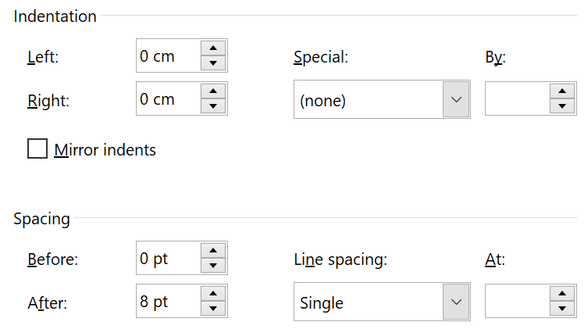

Lists
Lists may be bulleted or numbered. Font: Times New Roman. Size: 12. Left justified. Left indent: 1cm. Hanging indent: 0.5cm.
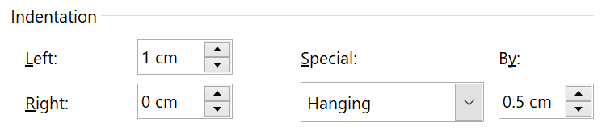
Example:
- List item one.
- List item two.

Numbers
In the text, write out numbers up to and including ten except as part of a date, a fraction or decimal, a percentage, or a unit of measurement. Use numbers from 11 onwards, except if it’s the first word of a sentence, in which case, write it out as text.

Abbreviations
Use abbreviations of the customary units of measurement only when they are preceded by a number, for example, “5 min” but “several minutes”. Write “percent” as one word, except when used with a number, for example, “several percent” but “25%”.

Acronyms
Avoid acronyms unless absolutely necessary. Write out the acronym in full the first time it’s used followed by the acronym itself in brackets.
Example:
Chartered Institute of Ergonomics & Human Factors (CIEHF)

Tables
Tables should be clear and fit into the normal width of a page in portrait orientation.
Tables should be numbered from 1, written as a number followed by a colon, and the title, all placed above the image. Tables should be referenced in the text near to the table. Put a single paragraph spacing after the table.
Table heading: Font: Times New Roman. Size: 12. Left justified.
Table text: Font: Calibri. Size: 11.
Example:
Table 1: My favourite things
My favourite things | Good for health | Times per week | Cost | Good for sharing
Wine | Maybe, in moderation | No comment | ££££ | Yes
Chocolate | No | Once? | £ | No!
Dogs | Absolutely | All day, everyday | ££ | Yes
Holidays | Definitely | If only! | £££££ | Yes
Swimming | Yes! | Twice | £ | No

Figures
Figures can be full colour, and should be clear, easy to read and unambiguous. Figures should be numbered from 1, written as a number followed by a colon and the title, all placed beneath the image. Figures should be referenced in the text near to the figure. Font: Times New Roman. Size: 12. Left justified. 8pt line spacing after.
Example:
Figure 1: Brain functions

References
References should be cited in alphabetical order of first author surname and year. Font: Times New Roman. Size: 12. Left justified. Hanging indent: 1cm.
Example:
Colston, H. L., & Katz, A. N. (2004). Figurative language comprehension: Social and cultural influences. Mahwah, NJ: Erlbaum.

The template
The template starts on the next page with the correct layout for the page set up and margins, title, authors, affiliations, abstract, keywords and first heading.
Remember: the maximum number of pages is two for your initial submission and 8 pages for your final paper.

Template for your submission to EHF2024
DOUBLE BLIND REVIEWS: DO NOT COMPLETE THE AUTHOR NAMES OR AFFILIATIONS UNTIL YOU SUBMIT YOUR FINAL PAPER. When you do submit your final paper, delete this red text.
Author One¹, Author Two² & Author Three³
¹Author One affiliation, ²Author Two affiliation, ³Author Three affiliation

SUMMARY
The summary should give an overview of your paper in 2-3 descriptive sentences.
KEYWORDS
Keyword 1, keyword 2, keyword 3

Content
You could include an introduction or a method section or whatever is the best way to describe your work. An introduction should set the stage for the importance of the work and draw the reader in. The scope and impact should be clearly stated. You could treat this like an extended abstract for the initial two page paper.

