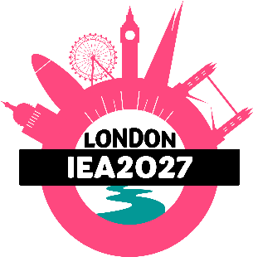
Workshop Proposal
We’re looking for proposals for 90-minute interactive workshops teaching delegates ergonomics and human factors methods, tools and techniques. Workshops require careful planning and management to deliver high value CPD (continuing professional development). To ensure your proposal can be considered for inclusion in the congress programme, please provide all the following information:
Your details (as workshop presenter)
Full name
Email
Job title / position
Organisation
Biography (highlight your relevant expertise, experience and why you should lead this workshop)
Summary of your proposed workshop
Title: Compelling, descriptive but concise.
Target audience and prerequisites: Specify the skill level (beginner, intermediate, advanced) and any prior knowledge attendees need to have.
Learning outcomes: List 3-5 clear, specific, actionable takeaways. (Use action verbs like create, analyse, design, or implement.)
Description: Give 200-300 words outlining the core problem your workshop solves, why it matters now, and the method, tool or technique attendees will be taught.
Interactive Format & Timeline: Break down your 90-minute session, detailing the times and balance of presentation, group activities and hands-on exercises, and Q&A.
Potential sponsors: Give contact details of any potential sponsors your workshop might attract. (We will follow up with them.)
Further details
Give any other comments or details you think are relevant to this proposal.

