Professional Competencies Checklist
What it is and how to use it
A checklist of professional competencies has been developed as a guide to expected competencies for qualification as an ergonomist and human factors specialist. It is already in use as an assessment tool for CIEHF accreditation of degree courses.
It can be used in conjunction with a proficiency scale to show progress in breadth and depth of skills and expertise as your career progresses.
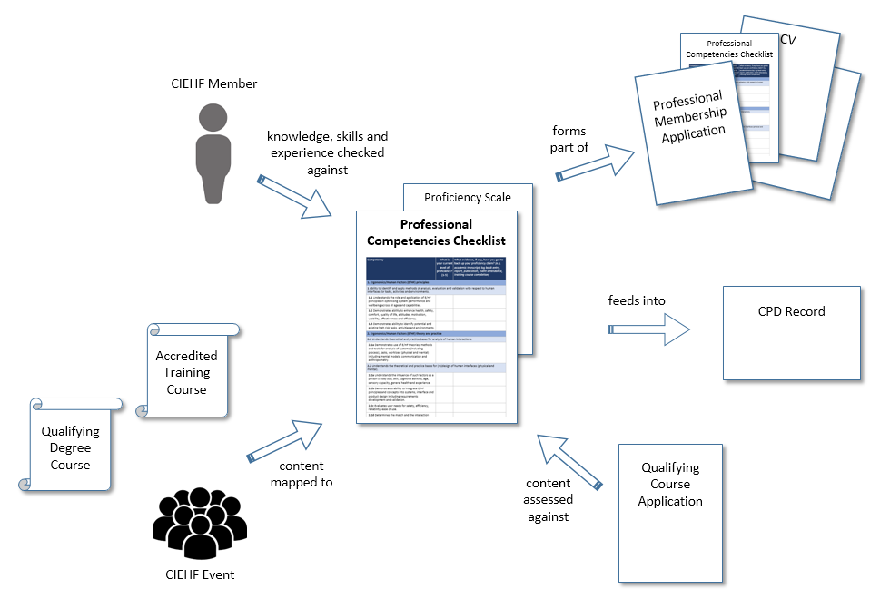

Use of the checklist for membership applications
For professional membership (Registered Member, Technical Member and Fellow), it will form part of the application and will be used to help demonstrate breadth (through the number) and depth (through levels of proficiency) of claimed competencies.
If you are planning to upgrade to Registered Membership, it might help you to complete the checklist as soon as you can. This will allow you to see any areas where you are particularly strong which might guide your log book entries or where you might need to fill any gaps. You will need to give evidence for your proficiency claims and examples of these could be log book entries, training courses or a publication.

Use of the checklist as an aid to professional development
All members are encouraged to consider use of this checklist as an aid to their career development. This is optional but you might find it a useful tool in assessing your continuing professional development (CPD). It may be helpful to use this list in conjunction with your employer’s work planning cycle.
It could be used as an ongoing record of the breadth and depth of your competency in ergonomics and human factors based on the number of competencies you feel you have proficiency in and the level of that proficiency. Used this way, it would show you where you have gaps in your competency or where you need to increase your level of proficiency based on your membership grade, role and career aspirations. This would help to guide your CPD activities, although there would be no requirement to submit this checklist with your CPD submission.

Expected breadth of competence and levels of proficiency
CIEHF-accredited ‘Qualifying’ degree courses have been assessed against this checklist as providing learning for every competency listed. Those graduating from such a course should have at least an awareness of every competency. As your career progresses and experience increases, your level of proficiency will increase, as it should for any member of any grade who is committed to their continuing professional development.
There are 6 levels of proficiency as follows:
0 = Unaware 1 = Aware 2 = Novice 3 = Intermediate 4 = Advanced 5 = Expert
For a detailed explanation of this proficiency scale, please refer to table 1 at the end of this document.
It would be expected that your proficiency would increase as your career progresses and you become more competent. Which level of proficiency would be attributable to which competency will depend on your level of experience, seniority and your exact career path. No-one would be expected to become ‘expert’ in all competencies.
Depending on the route you have taken in your career, you might have proficiency in a variety of competencies, but as a guide:
Grade of membership being applied for | Expected length of time in practice | Expected breadth of professional competencies | Expected range of proficiency levels
Student Member | - | - | 0 - 1
Graduate Member | On graduation | 100% | 1 - 3
Technical Member | 2 years | 60% | 1 – 4*
Registered Member | Minimum 3 years | 100% | 2 – 4**
Fellow | 10 years | 100% | 3 - 5

* Applicants must have at least an awareness (proficiency level 1) of a minimum of 60% of the competencies listed in the CIEHF Professional Competency Checklist and have higher proficiency levels in at least one of the sections.
** Applicants must have proficiency levels 3-5 in the majority of competencies and at least proficiency level 2 in all the rest.

Filling the gaps
The content of each Qualifying degree course and CIEHF-accredited training course will be mapped against the competencies, as will the content of each CIEHF event. This will help you to find CPD activities that could fill the gaps in your competencies or help to raise your proficiency level.

The checklist
The checklist is split into 5 sections:
- Ergonomics/Human Factors (E/HF) principles
- Ergonomics/Human Factors (E/HF) theory and practice
- Human capabilities and limitations
- Design and development of systems
- Professional skills and implementation
Each section is further split into individual competencies. The checklist can be used to record levels of proficiency for each competency and the supporting evidence for each proficiency claim.

Competency | What is your current level of proficiency?  (1-5) | What evidence, if any, have you got to back up your proficiency claim? (e.g. academic transcript, log book entry, report, publication, event attendance, training course completion)
Section 1: Ergonomics/Human Factors (E/HF) principles
1 Ability to identify and apply methods of analysis, evaluation and validation with respect to human interfaces for tasks, activities and environments.
1.1 Understands the role and application of E/HF principles in optimising system performance and wellbeing across all ages and capabilities.
1.2 Demonstrates ability to enhance health, safety, comfort, quality of life, attitudes, motivation, usability, effectiveness and efficiency.
1.3 Demonstrates ability to identify potential and existing high risk tasks, activities and environments.
Section 2: Ergonomics/Human Factors (E/HF) theory and practice
2.1 Understands theoretical and practice bases for analysis of human interactions.
2.1a Demonstrates use of E/HF theories, methods and tools for analysis of systems (including process), tasks, workload (physical and mental) including mental models, communication and anthropometry.
2.2 Understands the theoretical and practice bases for (re)design of human interfaces (physical and mental).
2.2a Understands the influence of such factors as a person’s body size, skill, cognitive abilities, age, sensory capacity, general health and experience.
2.2b Demonstrates ability to integrate E/HF principles and concepts into systems, interface and product design including requirements development and validation.
2.2c Evaluates user needs for safety, efficiency, reliability, ease of use.
2.2d Determines the match and the interaction between human characteristics, abilities, capacities and motivations, and the system(s), organisation, planned or existing environment, products used, equipment, work systems, machines and tasks.
2.2e Understands the management of E/HF risks, including priorities and mitigations; potential benefits and costs of E/HF solutions; short and long term goals relevant to defined problems.
2.2f Can apply relevant legislation, codes of practice, standards (government and industry).
2.2g Determines whether the interface or interaction is amenable to E/HF intervention.
2.3 Understands the theoretical and practice bases for data collection and analysis relating to E/HF.
2.3a Understands the type of quantitative and qualitative data required for E/HF appraisal and design; selects and validates the proposed collection/analysis methods and tools.
2.3b Understands and can apply the basics of experimental design and statistics.
2.3c Understands and can apply the basics of qualitative study design and analysis including knowledge elicitation, interviews, document analysis, and observation.
2.3d Demonstrates ability to seek and obtain relevant ethical approval for E/HF data collection and analysis.
Section 3: Human capabilities and limitations
3.1 Understands the theoretical and practice bases for E/HF relating to physical capabilities and limitations.
3.1a Demonstrates a working knowledge of anatomy, functional anatomy, anthropometry, physiology, pathophysiology, and environmental sciences as they apply to E/HF practice.
3.1b Can apply knowledge of biomechanics, anthropometry, motor control, energy, forces applied as they relate to stresses and strains produced in the human body.
3.1c Understands the effects of the environment (including acoustic, thermal, visual, vibration) and individual sensory response (sight, hearing, touch, taste, smell) on human health and performance.
3.2 Understands the theoretical and practice bases for E/HF relating to psychological and social capabilities and limitations.
3.2a Understands theoretical concepts and principles of social and psychological sciences relevant to E/HF.
3.2b Recognises psychological characteristics and responses and how these affect health, human performance, attitudes, perception, stress, human reliability and error.
3.2c Can apply knowledge of human information processing (including situation awareness, memory, decision making).
3.2d Demonstrates a knowledge of systems theory including socio-technical systems and culture (e.g. organisational and safety culture).
3.2e Understands the principles of group functioning, motivation, engagement and participation.
3.2f Understands the principles of organisational management including individual, group (team) and organisational change techniques, including training and work structuring.
Section 4: Design and development of systems including products, tasks, jobs, organisations and environments
4.1 Understands the theoretical and practice bases for E/HF relating to design and development of systems.
4.1a Understands basic engineering (technology) concepts, with a focus on design solutions and contextual operation of technologies.
4.1b Demonstrates an understanding of the principles of E/HF and human-machine interface technology including hardware, software, internet and network based technologies and social media.
4.1c Understands the requirements for safety systems, the concepts of risk, risk assessment and risk management.
4.2 Utilises a systems approach to the human-aspects of the specification, design, assessment and acceptance of products, services and human factors interventions.
4.2a Applies E/HF principles to design of systems (and services), products, job aids, controls, displays, instrumentation and other aspects of tasks and activities.
4.2b Understands the iterative nature of design development including simulation and computer modelling.
4.2c Considers the options for achieving a balance between human and technological, task and environment to achieve an optimal system.
4.2d Selects appropriate forms of E/HF solutions and recommendations based on theoretical knowledge and practice, and develops a comprehensive, integrated and prioritised approach.
Section 5: Professional skills and implementation
5.1 Understands role of E/HF in change strategies.
5.1a Provides design specifications and guidelines for technological, organisational and E/HF design or redesign of the work process, the activity and the environment which match the findings of E/HF analysis.
5.1b Develops strategies to introduce a new design to achieve a healthy and safe human interaction.
5.1c Recognises the safety hierarchy, application of primary and secondary controls and the order of introducing controls.
5.1d Recommends personnel selection where appropriate as part of a balanced solution to the defined problem.
5.1e Interacts effectively with clients at all levels of personnel.
5.2 Develops appropriate recommendations for education and training in relation to E/HF principles.
5.2a Understands current concepts of education and training relevant to application of E/HF principles.
5.2b Implements effective education and training programmes relevant to understanding the introduction of E/HF measures.
5.3 Supervises the application and evaluation of an E/HF plan.
5.3a Implements appropriate design or modifications.
5.3b Incorporates methods to allow continuous improvement.
5.3c Selects appropriate criteria for evaluation.
5.3d Produces clear, concise, accurate and meaningful records and reports.
5.4 Shows a commitment to ethical practice and high standards of performance and acts in accordance with legal requirements.
5.4a Behaves in a manner consistent with accepted codes and standards of professional behaviour.
5.4b Recognises the scope of personal ability for E/HF analysis and when it is necessary to consult and collaborate with different professional experts.
5.4c Demonstrates commitment to ongoing professional development by maintaining skill set and an awareness of wider E/HF practice.

Table 1: Proficiency Scale
Score | Proficiency Level | Description
0 | Unaware | You have no knowledge or understanding of this competency.
1 | Aware | For a particular competency: You have knowledge or an understanding of basic techniques and concepts.  Your professional development: Your focus is on learning more.
2 | Novice  (basic) | For a particular competency: You have limited experience gained in a classroom and/or as a trainee on-the-job. You are expected to need help with this competency. Your focus is on developing through on-the-job experience. You can understand and discuss terminology, concepts, principles and issues, and can use reference and resource materials related to this competency.  Your professional development: Your CPD shows responsibility for, and awareness of, your own learning and professional development.
3 | Intermediate  (skilful) | For a particular competency: You can successfully complete tasks in this competency independently, though you may need help from an expert. Your focus is on applying and enhancing your knowledge or skill. You understand and can discuss the application and implications of changes to processes, policies, and procedures in this area.  Generally: You show awareness of how even a narrowly focused task can draw upon knowledge crossing a variety of different knowledge areas. You can demonstrate the appropriate use of different techniques and methods in the application of human factors research or consultation.  Your professional development: Your CPD demonstrates learning outside of your immediate job requirements. Your forward plan shows how you will learn new skills to complement your career path such as management, business administration, marketing, personnel management.
4 | Advanced  (mastery) | For a particular competency: You can perform the actions associated with this competency without assistance. You are recognised within your organisation as the go-to person regarding this competency. Your focus is on broad organisational/professional issues. You participate in senior level discussions regarding this competency. You assist in the development of reference and resource materials in this competency, and are capable of training others.  Generally: You have responsibility for integrating and delivering programmes of work and meeting deadlines and milestones. You mark, grade and review the work of others in the context of project delivery. You bring together disparate theories and techniques or the application of novel solutions to complex problems. You demonstrate use and application of multiple tools and techniques to more complex projects that require human factors integration. You present the output of work and research undertaken.  Your professional development: Your CPD shows awareness of knowledge and skill fade in areas not being practised due to career specialism and provides a plan to compensate. You show consideration of the development of your management and administrative skills so you have greater autonomy and authority over project delivery.
5 | Expert | For a particular competency: You are known as an expert or recognised authority in this area. You can provide guidance, troubleshoot and answer questions related to this area of expertise. Your focus is strategic. You have demonstrated consistent excellence in applying this competency across multiple projects and/or organisations. You are considered the go-to person in this area within and outside your organisations. You create new applications for and/or lead the development of reference and resource materials for this competency.  Generally: You contribute to the development and success of the discipline possibly through voluntary activities within the CIEHF. You interact with other strategic thinkers within your community of expertise.  Your professional development: Your CPD demonstrates communication of learning, teaching or mentoring of others.
Table adapted from NIH Competencies Proficiency Scale https://hr.od.nih.gov/workingatnih/competencies/proficiencyscale.htm

